


The West Lothian Inclusion and Wellbeing Service ran the SQA L4/5 Mental Health and Wellbeing Course for the first time during session 19-20. In my class we had 6 pupils from across 4 schools and ran the course at our Skills Centre in Whitburn. It was a very successful group which not only educated the pupils on their understanding of mental health but also provided an opportunity to focus on ways to improve their own wellbeing and self-esteem.

Here is an audio clip from part of a discussion we had as a class in February.
In it the pupils say “This is why I am happy I joined this group. Before I did I didn’t know anything really about the disorders. I just saw depressed as being sad, anxiety as being not wanting to go somewhere and bipolar as happy then sad. There’s so much more to it and I don’t think people actually understand this. If everyone did this course then they would probably understand more.”
Here are some examples of things we did during our classes:

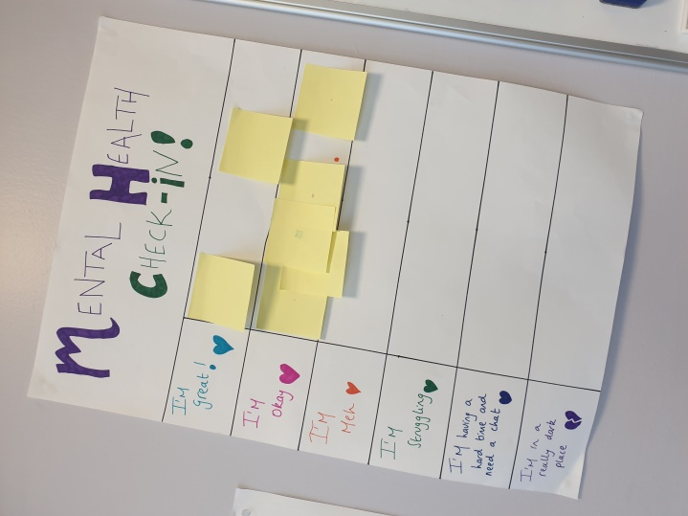
Mental Health Check-in
Our classes always started with a check-in where staff and pupils would put a post-it note on the section which best fit how they were feeling that day. Depending on how the class were feeling I would maybe incorporate more wellbeing activity time. I remember this class in particular as it was the first time everyone was okay or great.
Exploring Mental Health Conditions with Lego
Pupils used lego to build and show their understanding of some mental health conditions.
Depression –
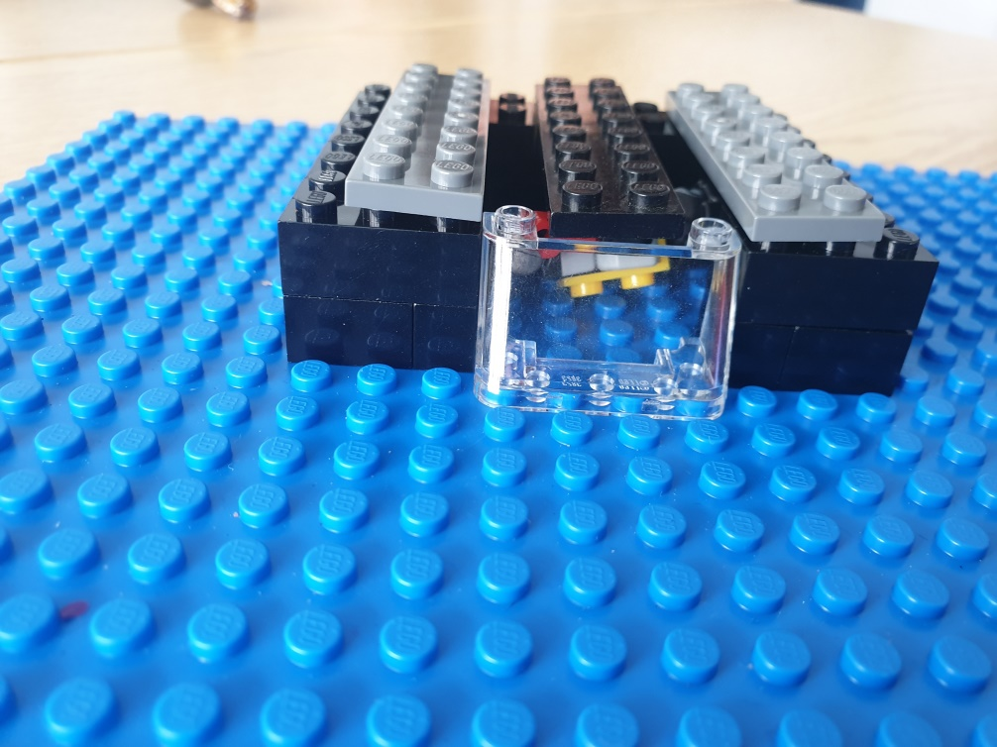
“It doesn’t matter how much positivity you are surrounded by, you still feel the same.
You feel trapped and stuck in a bad place”

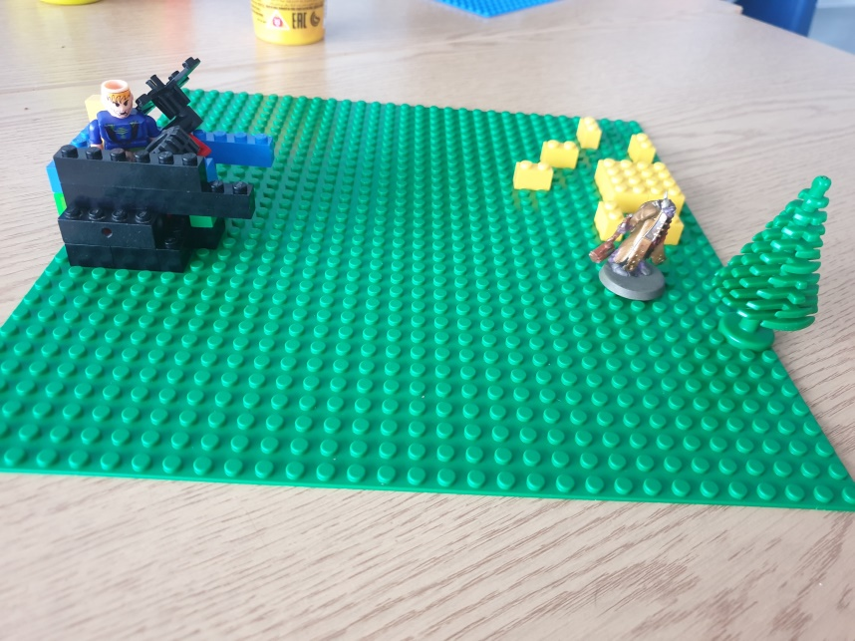
“Feel like in a black hole – overloading them, stuck in with their problems. All friends are outside having fun and they are not.”

Anxiety –
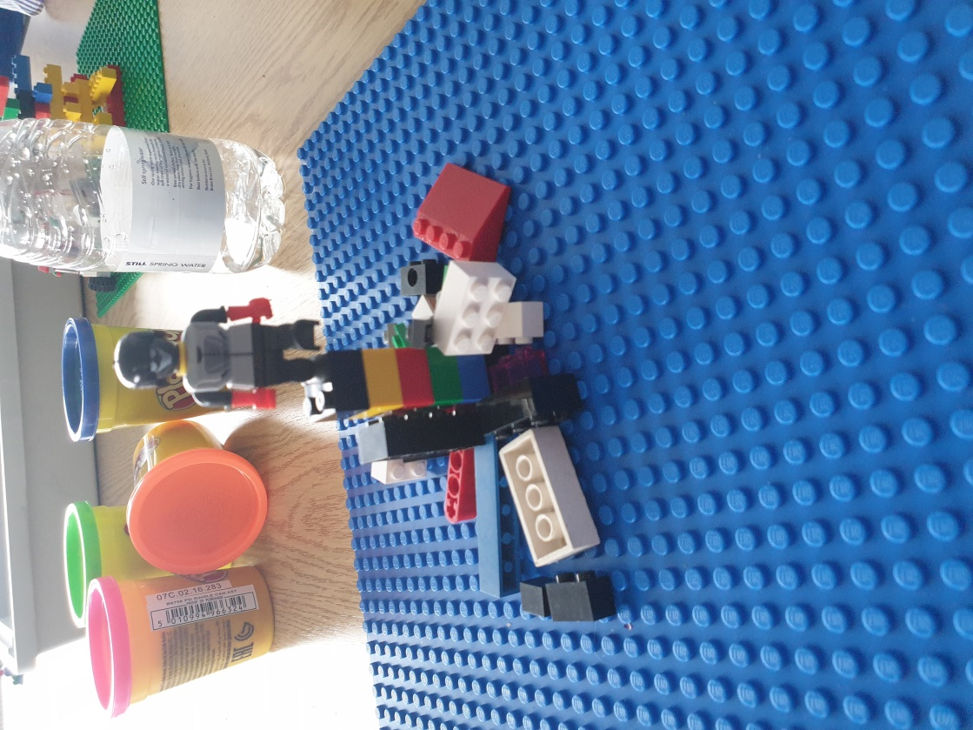
“Feel on edge. Feel like there is lots of stuff going on around you.”

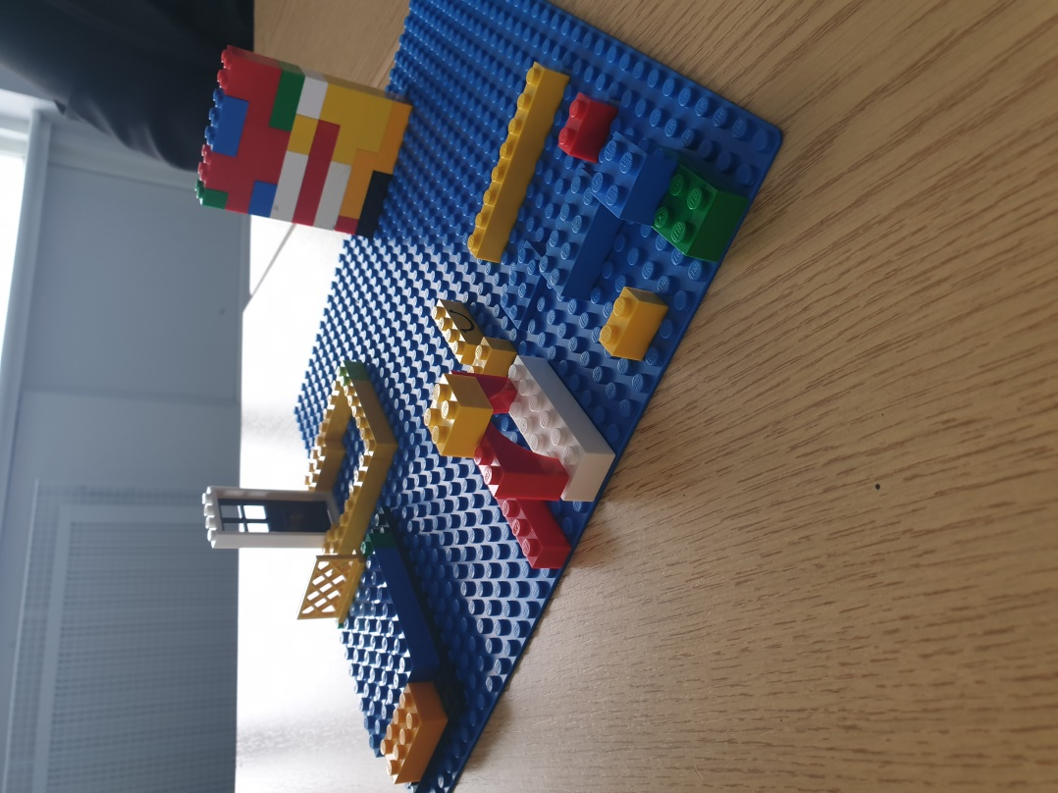
“Feeling all over the place.
Huge wall to climb. Feel trapped and locked out. Want to stay in bed all day.”

Impacts on our Mental Health
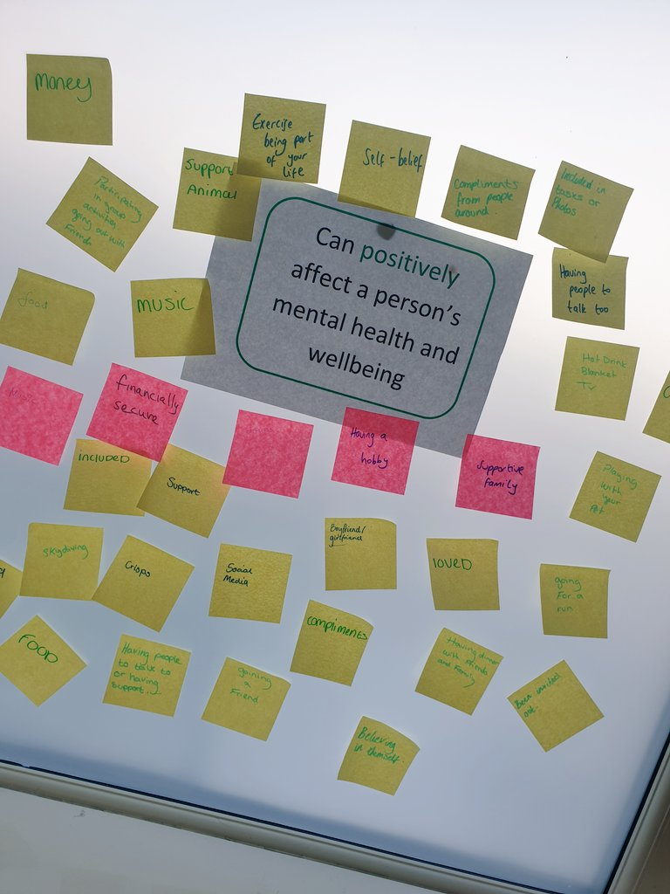
We discussed the many different things that impact our mental health in either a positive or negative way. We ran out of post-it notes on this activity!
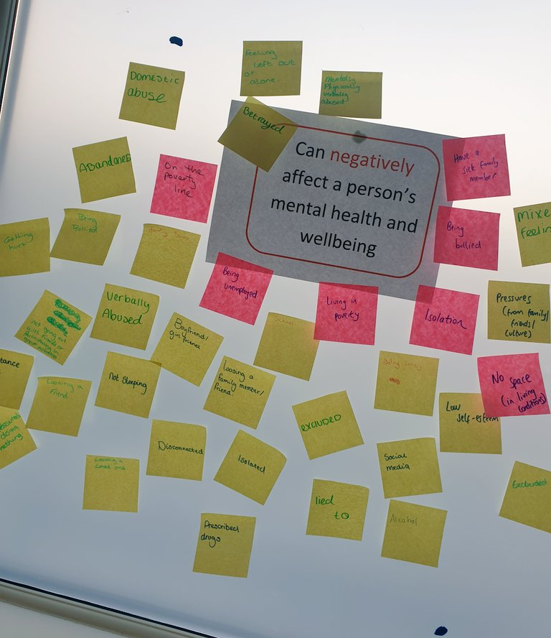
Giggle Journals
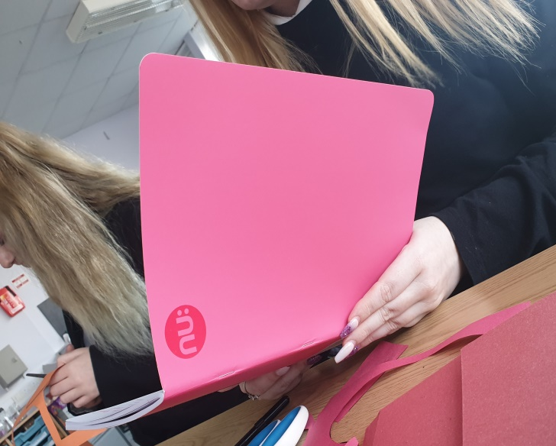
All pupils had a “giggle journal” which was a place to write down stories/memories which made them laugh or smile. The idea was that this could be used in the future when not having such a good day as a tool/coping strategy that might help them. Sometimes pupils chose to read out what they had written.
Self-Soothe Boxes
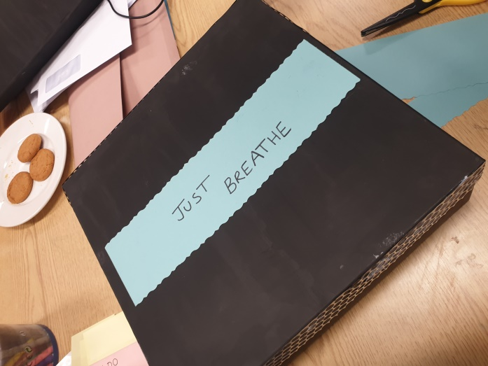
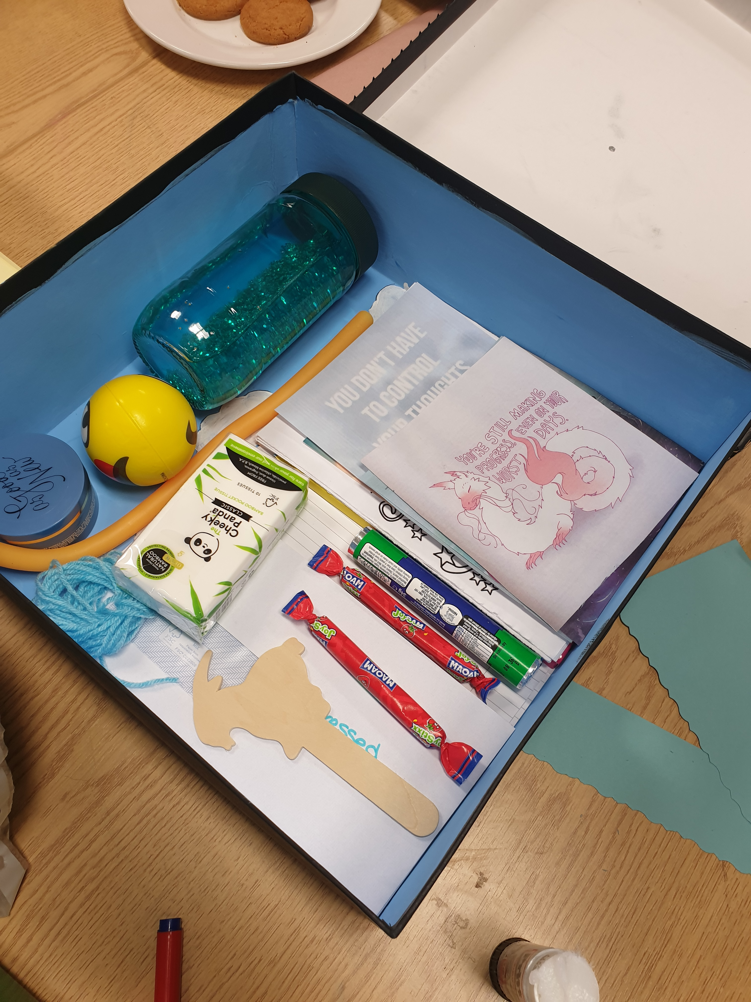

All pupils made self-soothe boxes and included items which might help them in a time when they were struggling.
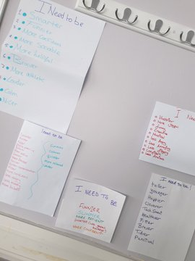
Self-Esteem Challenge
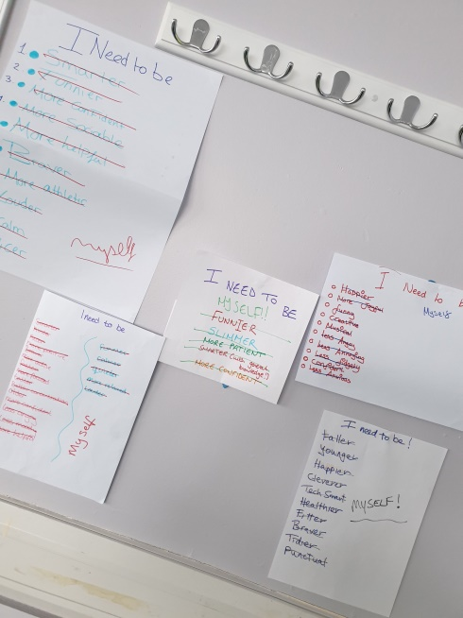

After a discussion around the pressure young people can put on themselves to act or look a certain way and the role social media plays in this all pupils wrote down a list of things of everything they felt they needed to be. We then challenged this by scoring through each one and acknowledging that they only need to be themselves.

